

UNIVERSITY OF BUEA
FACULTY OF ENGINEERING AND TECHNOLOGY
DEPARTMENT OF COMPUTER ENGINEERING
CEF440 INTERNET PROGRAMMING AND MOBILE PROGRAMMING

PROJECT TITLE: DESIGN AND IMPLEMENTATION OF AN ADAPTIVE E-LEARNING PLATFORM BASED ON QUALITY OF EXPERIENCE FOR INCLUSIVE ONLINE EDUCATION IN LOW – RESOURCE SETTINGS.

TASK 2
Group 15 Report
COURSE INSTRUCTOR: Dr Nkemeni Valery

NAME | MATRICULE
NJINYA NGECHA RYAN BROWN | FE23A116
KARL JONAS WENGE ACHA | FE23A072
TAKU-MBI INYANG | FE23A153
BRIANNA TEBESICK TSAMO | FE23A028
KELSEY NJOCK-AWOH NJOCK OBEN | FE23A073

TABLE OF CONTENT
INTRODUCTION
STAKEHOLDER IDENTIFACTION
REQUIREMENTS GATHERING TECHNIQUES
DATA GATHERING
DATA CLEANING
USER RELUCTANCE ASSESSMENT
CONCLUSION

INTRODUCTION

In many African countries today, poor network quality and unstable power supply serves as a hinderance to e-learning. The aim of this project is to design and implement an adaptive mobile e-learning platform that dynamically adjusts content delivery and communication features based on network conditions, to optimize quality of experience in low – resource environments.
Requirement gathering is an important phase in system development, because it helps developers understand user needs, challenges, and expectations before designing the system. This report presents the stakeholders involved, the techniques used to gather requirements, the data collected, the data cleaning process, and the assessment of user reluctance toward using online learning platforms.

STAKEHOLDERS IDENTIFACTION
After we did careful individual research to understand what our project is all about, we sat down together to identify the stakeholders of our system. We identified 5 Stakeholders of our system which we grouped into primary and secondary stakeholders.

Primary User Stakeholders
These refer to individuals who interact with our system. Their feedback is the core metric of our Quality of Experience assessment. They include:
- Diverse Learners. That is, students with varying levels of digital literacy, different socio-economic backgrounds, and those with physical or cognitive disabilities. These learners, include people at all educational levels.
- Instructors (Educators and Facilitators). They include university lecturers, primary school teachers and secondary school teachers who create and manage content and aim to deliver lessons regularly and effectively.
- Parents & Guardians: They include parents of children in primary and secondary schools as they are concerned about their children’s academic progress and are their financial providers especially in low-resource settings.
- School Administrators. They include heads of establishments like proprietors, head teachers, vice-principals, principals, heads of departments, deans and vice-deans, and vice-chancellors.

Secondary Stakeholders
These are stakeholders that are able to influence the use of e-learning systems in low-resource settings. They include;
- Ministries in charge of Education: In Cameroon for example, they include ministry of basic education, ministry of secondary education and ministry of higher education as these ministries support and regulate the educational system by making policies, providing resources, and ensuring quality of education.

REQUIREMENTS GATHERING TECHNIQUES
After careful study of various requirement gathering techniques, we decided to make use of four requirement gathering techniques, brainstorming, Observation, Reverse Engineering and Surveys.

Brainstorming
As a team we conducted a brainstorming session to identify possible features and challenges in online learning systems. During the session, we discussed issues such as poor network quality, limited power supply, limited device availability and the need for offline learning support.
The brainstorming process helped us to generate ideas for system features such as adaptive content delivery, low-bandwidth mode, and mobile compatibility.

Observation
We observed carefully how lecturers teach, the tools they use, how they test understanding, the duration of lessons and how comfortable they are with technology. We also observed students interaction with lecturers, their duration of focus, their interaction with their peers during lessons, and their familiarity with technology.

Reverse Engineering
We studied four (4) existing systems to understand their functionality and limitations. We focused on system featured, performance under low internet conditions and usability. This helped to identify improvements needed for the proposed adaptive E-learning platform.

Eneza
Eneza is designed specifically for low-resource environments and works on basic phones.
Features
- Lessons, quizzes, and assessments delivered through SMS, USSD, and mobile web
- “Ask a Teacher” feature for academic support
- Performance tracking dashboards for students, teachers, and parents
- Curriculum-aligned content for core subjects
- Works on basic feature phones and low bandwidth networks
Problems it does not solve
- It provides mostly text-based learning, so multimedia learning is limited
- It depends on mobile network availability and airtime credit
- It may not support advanced interactive or collaborative learning tools
- It does not solve infrastructure issues like electricity or device shortages
How it dynamically adjusts content delivery and communication
Eneza optimizes content delivery mainly by:
- Using lightweight technologies like SMS and text-based lessons
- Delivering small “bite-sized” learning content
- Operating on very low bandwidth or basic mobile networks

Moodle
It is a flexible learning management system
Features
- Course management and assignment submission
- Discussion forums and messaging
- Mobile learning through the Moodle app
- Offline access to course materials
- Downloadable resources and assessments
Problems it does not solve in low-resource settings
Despite its flexibility, Moodle still faces several challenges:
- It requires digital literacy from teachers and administrators
- Course design quality depends on the teacher
- Heavy multimedia content can increase bandwidth usage
- It may require servers and technical support
How it dynamically adjusts content delivery and communication
Moodle adjusts delivery and communication using:
- Offline mode with automatic synchronization
- Mobile-friendly design
- Downloadable course materials
- Microlearning (small content units)

Kolibri
Kolibri is designed as an offline-first learning platform for schools with limited internet
What features it has.
- Offline access to videos, exercises, and digital textbooks
- Local server or device-based content distribution
- Teacher dashboards and student performance tracking
- Ability to upload locally created learning materials
- Access through Wi-Fi without internet connection
Problems it does not solve in low-resource settings
Kolibri still has some limitations:
- Requires devices such as tablets or computers
- Needs initial setup and planning by teachers
- Limited content availability in some languages
- Originally designed for classroom environments
How it dynamically adjusts content delivery and communication
Kolibri optimizes delivery mainly through offline infrastructure:
- Content is stored locally on a device or server
- Students connect through local Wi-Fi instead of the internet
- Content can be shared across multiple devices

YouTube
We found that YouTube is widely used for learning because of its multimedia capabilities.
What features it has
- Video streaming for educational content
- Search and recommendation system
- Comments and communication features
- Download option for offline viewing
- Wide range of educational channels
Problems it does not solve in low-resource settings
However, YouTube is not fully designed for low-resource environments. Some problems include:
- High data consumption for video streaming
- Requires reliable internet connection
- Limited control over content quality
- Distractions from non-educational content
How it dynamically adjusts content delivery and communication
YouTube uses advanced adaptive streaming technology, including:
- Automatic video quality adjustment based on network speed
- Dynamic bitrate selection
- Buffer management to reduce interruptions

Surveys
We conducted a survey to collect information from students, teachers, parents and school administrators. The survey focused on internet availability, device usage, learning challenges, and preferred system features.
For learners, we tried to understand their network quality, the type of devices they use, how power outages affect their learning, their experience with online learning systems, their expectations of online learning systems, their duration of focus for online lectures and how comfortable they are when it comes to using e-learning systems.
For parents we tried to their expectations of an e-learning system, their experience with e-learning for their children, how power outages affect their children’s learning and their concerns about e-learning.
For school administrators, we tried to identify their biggest challenge when it comes to e-learning, their priorities when it comes to implementing e-learning systems, and main functionalities they would expect from an e-learning system.
For instructors, we tried to understand their experience with using e-learning systems, the type of device they use, their biggest challenge when it comes to e-learning and their expectations from an e-learning system.
From our survey, we had a total of 95 responses, 82 responses from learners, 6 responses from instructors, 4 responses from parents, and 3 responses from school administrators.
Below is a link to our survey form: https://forms.gle/FErQueymbMWSNGds7

DATA GATHERING
From our survey we were able to get 95 responses, 82 responses from learners, 6 responses from instructors, 4 responses from parents, and 3 responses from school administrators.
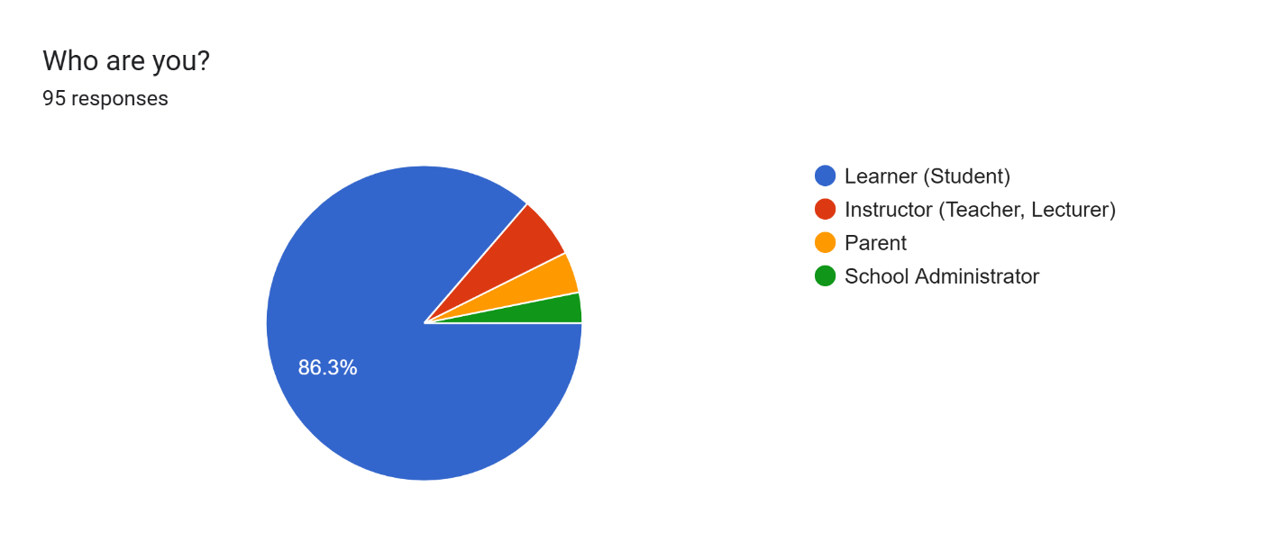
We also studied 4 existing systems. Eneza, Moodle and Kolibri which are existing e-learning systems in Africa and YouTube.
As a team, 4 of us sat together to brainstorm on possible features and present challenges faced in towns and villages in Africa when it comes to e-learning.

DATA CLEANING
After gathering data from the survey. We reviewed the data to remove errors and improve accuracy. Incomplete responses, duplicate entries, and invalid data were removed from the dataset. After cleaning the data, only valid responses were used for analysis

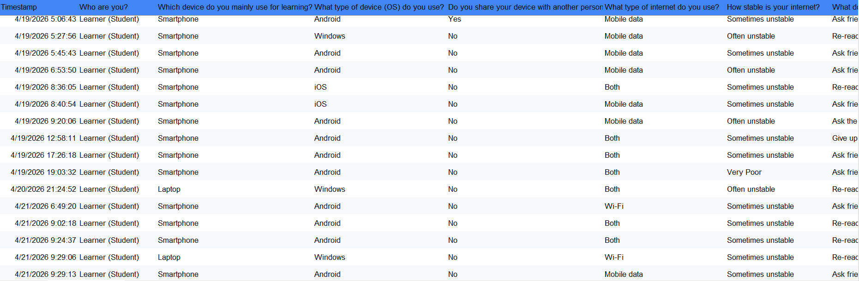

USER RELUCTANCE ASSESSMENT

USER RELUCTANCE ASSESSMENT FOR REQUIREMENT GATHERING
While carrying out the survey we got in contact with many people but, some were afraid of clicking the link to the form as they feared that their devices might be hacked, this made it difficult to get more responses. Some others, though they are teachers and parents, felt that the form does not apply to them. While others were unwilling to participate in the survey.

USER RELUCTANCE ASSESSMENT FOR OUR SYSTEM
In our survey form we included questions to understand why users may be reluctant to use our system.
For students we included questions like:
How stable is your internet?
What makes online learning difficult for you?
Do you believe online learning is as effective as classroom learning?
Is the cost of internet/data a challenge for participating in online learning?

For parents we included questions like:
How often can your child use his/her device or your device for learning?
Can you afford internet data for your child?
Are you familiar with e-learning platforms?
Do you trust online learning for your child's education?
Are you able to assist your child with online learning?
What concerns do you have about e-learnng for your child?

For school Administrators:
How affordable is implementing an e-learning system for your institution?
What concerns do you have about e-learning systems?

For Teachers:
Does using an e-learning platform increase your workload?
What challenges do you face when using e-learning platforms?

From our survey, 73.2% say cost of data makes online learning difficult for them and 69.5% of learners say internet issues make online learning difficult for them. Indicating that many learners may be reluctant to use our system because of cost of data and internet issues.
From our survey, 75% of parents worry about the cost of data for e-learning and 50% of them do not trust online learning for their children’s education. This indicates that many children may not use our system because their parents fear the cost of data and do not trust online learning for their children’s education.
From our survey, 66.9% of school administrators feel that implementing an e-learning system for their institution is not affordable. Indicating that school administrators may not use our system because of cost.
From our survey 66.7% of instructors feel that using an e-learning system increases their workload and 80% say poor network quality is a challenge.

After assessing user reluctance, we were able to identify some solutions which are shown in the table below

Reluctance Issue | Solution
High data cost | Low-data mode, allow offline access, compress videos and images,
Poor network quality | Be able to work on Low bandwidth network, provide recorded lessons, use lightweight web apps or mobile apps that load quickly, use caching
Lack of trust in e-learning systems | Secure login systems, certified instructors, technical support and help desk

CONCLUSION
The requirement gathering process helped us understand the needs and challenges faced by users in low-resource environments. The findings will guide us in the design and implementation of an adaptive E-learning platform that improves accessibility, usability, and quality of experience.

